To install Office 365 on a Mac
Log into Office 365 from the portal. If you already have a version of office installed or are signed into O365 under a personal account you will need to close or sign out.
Once logged into O365 this should appear in the upper right corner. Click on the drop down arrow.
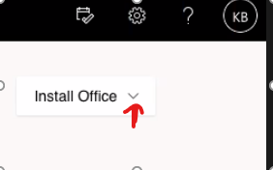
You will now see two options. Select the Other install options.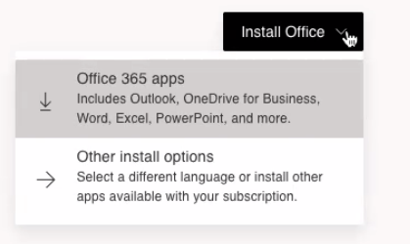
Now you will see Office Apps & devices. Select the View apps & devices.
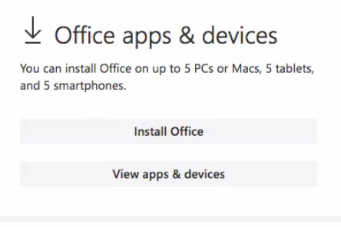
If you do not know what OS you have you can click on the apple in the upper left corner of the Mac and select about this mac to see the version number. If you have 10.13.6 or later you can click on the install office button. If it is older, then you will need to click the download link.
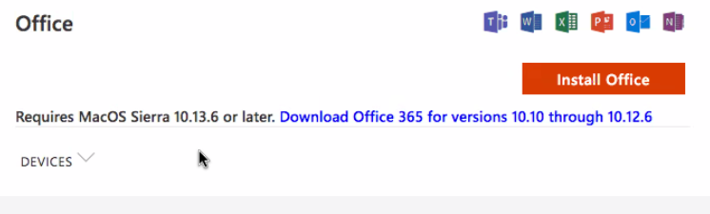
At this point the Mac should walk you through the installation.

