Troubleshooting password reset issues
If you get an error message when trying to reset your password at https://webapps.asumh.edu/changepassword here are a couple of items you might check.

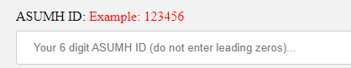
- Be sure you are using your 6 digit ID and not your username in the ASUMH ID: field.
- Be sure you are entering your birthdate with the slashes included and any leading zeros to make sure the total number of characters entered is 10. Example: 01/01/2000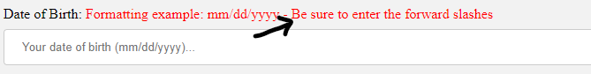

- Be sure your password is not one that you have used previously and meets the complexity requirements on screen. 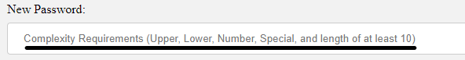

- Be sure you are not using a special characters such as (!, &, @, #, $) as the first character in your password.

